‘Reflections from a Film’

paintings by

CHRIS GOLLON
(1953 – 2017)

5th – 22nd August 2025
Sworders, 15 Cecil Ct, London WC2N 4EZ. london@sworder.co.uk
Open Mon – Friday 11am – 6pm

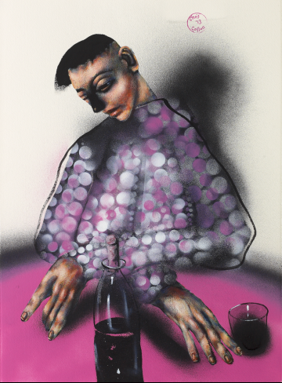

‘All Mixed Up’ by Chris Gollon © Chris Gollon Estate

Following the World Premiere of the new documentary ‘CHRIS GOLLON: Life in Paint’ (85mins)’ at the Barbican in autumn 2024, featuring Thurston Moore, Maggi Hambling, Sara Maitland, Eleanor McEvoy, art historians and writers, Sworders are delighted to exhibit for sale a selection of works recently released from the Chris Gollon Estate.

This is the first solo exhibition of the artist’s work in London, since his untimely death in 2017. The works reflect both subjects and techniques celebrated in the film. These include Chris Gollon’s interest in artistic boundary crossing between music and fine art, his sensitive portrayal of women, his ability to depict human drama in still life; and his innovative techniques in the modern medium of acrylic, combining Old Master techniques with printmaker’s rollers and fine art spray paints. View documentary trailer here: ‘CHRIS GOLLON: Life in Paint’

Chris Gollon biography below, and for further information or images, please contact:
Lizzie Lardner. E: press@sworder.co.uk. M: 07966 983855

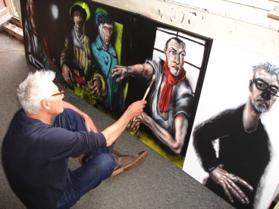
Chris Gollon in his studio circa 2014 © IAP Fine Art

Chris Gollon (1953 -2017) was a London-born artist who exhibited widely in the UK. His work is held in major public collections including the British Museum and Huddersfield Art Gallery.

In 1998, he exhibited at the Chisenhale Gallery, with Yoko Ono, David Bowie and Gavin Turk in ROOT, an exhibition of contemporary music and art created by Thurston Moore of Sonic Youth. Further boundary-crossing collaborations included working with Grammy-nominated classical virtuoso, Yi Yao (2014) and Irish singer-songwriter Eleanor McEvoy (2015 - 2017).

In 2000, Chris Gollon was commissioned by the Church of England to paint fourteen site-specific Stations of the Cross for the Grade I listed Church of St John on Bethnal Green, designed by Sir John Soane. Permanently installed in 2008, and subsequently blessed by Richard Chartres, Bishop of London, they inspired Sara Maitland’s book Stations of the Cross (Random House, London & New York) the same year.

In 2004, Gollon was invited to exhibit in St Paul’s Cathedral, with Bill Viola, Maggi Hambling, Craigie Aitchison and Tracey Emin in ‘Presence: Images of Christ for the Third Millennium’. In 2005, the Huddersfield Art Gallery purchased Gollon’s large work ‘Einstein & The Jealous Monk (after Bob Dylan)’ for its permanent collection to juxtapose with Jacob Epstein’s bust of Einstein.

In 2008, the River & Rowing Museum in Henley-on-Thames commissioned Chris Gollon to paint the Henley Royal Regatta, to hang alongside Raoul Dufy’s painting of the same subject in its permanent collection.

In 2009, Gollon was the first non-academic to be made a Fellow and First Artist in Residence at the Institute of Advanced Study, Durham University, and invited to work with some of the world’s leading thinkers on the Being Human project. That year, Chris Gollon and his work were featured on Alan Yentob’s Imagine (BBC1). In 2010, the monograph ‘Chris Gollon: Humanity in Art’ by art historian Tamsin Pickeral was published, endorsed by Bill Bryson OBE.

A sensitive painter of women, Gollon’s series of paintings ‘Incarnation, Mary and Women from the Bible’ became a national touring exhibition to English cathedrals, (2014 – 2016), including Norwich, Hereford, Durham and for Chichester he also painted the first image in art history of Judas Iscariot’s wife.

A year after his death, Romsey Abbey purchased and permanently installed his ‘St Ethelflaeda’ diptych. In 2019, ‘CHRIS GOLLON: Beyond the Horizon’ a museum retrospective of Chris Gollon’s music-related work was held at the Huddersfield Art Gallery.

In late 2024, the new documentary ‘CHRIS GOLLON: Life in Paint’ (85mins) was premiered at the Barbican Centre, London, and subsequently shown in New York in May 2025, featuring interviews with Maggi Hambling, Thurston Moore, Sara Maitland, Eleanor McEvoy, Yi Yao, with art historians and writers including Gollon biographer Tamsin Pickeral.

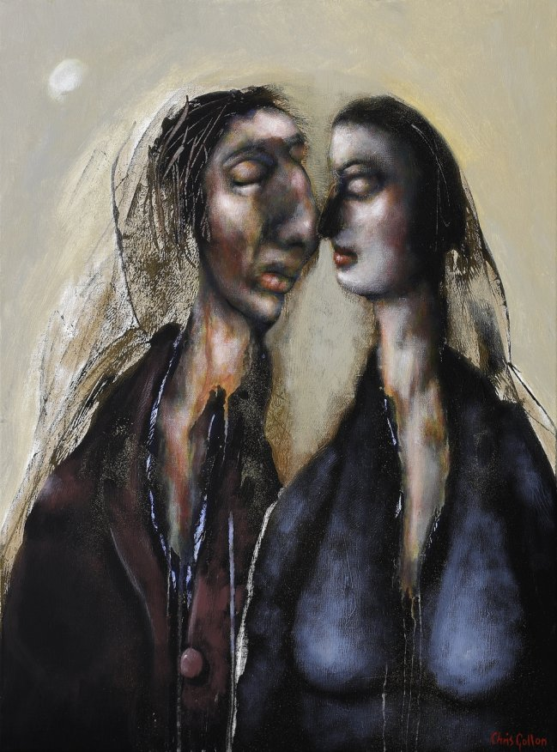

‘Love (II)’ by Chris Gollon, 24” x 18” (61 x 46cm) acrylic on canvas 2011. © Chris Gollon Estate

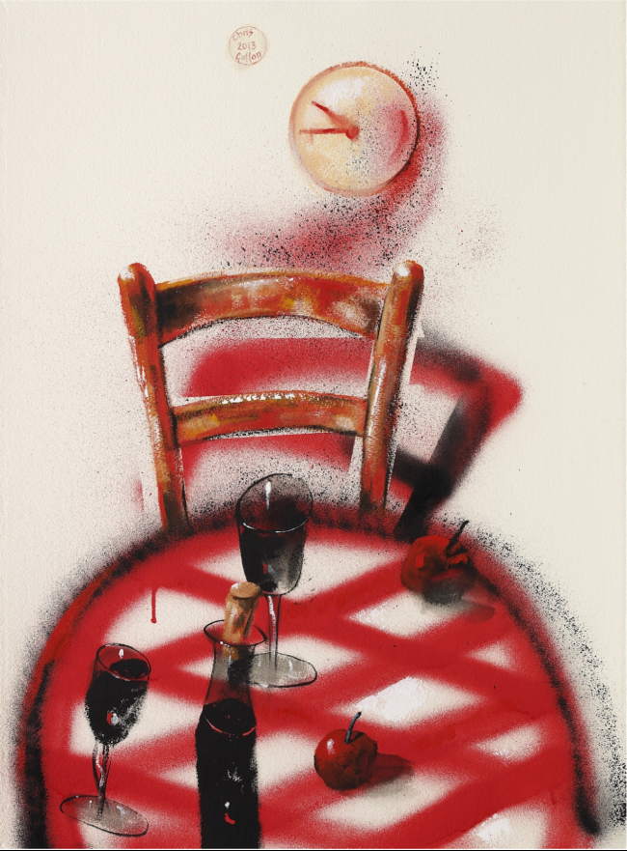

‘Still Life with Check Tablecloth’ by Chris Gollon, 30” x 22” (76 x 56cm) acrylic on paper 2013. © Chris Gollon Estate

