CHRIS GOLLON: ‘Reflections from a Film’

5 – 22 August 2025

Sworders & IAP Fine Art

15 Cecil Ct, London WC2N 4EZ
Open Mon – Friday 11am – 6pm

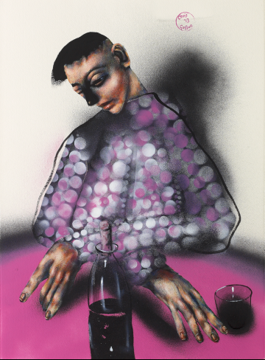

‘All Mixed Up’ by Chris Gollon © Chris Gollon Estate

Following the World Premiere of the new feature-length documentary ‘CHRIS GOLLON: Life in Paint’ at the Barbican Centre in October 2024, Sworders and IAP Fine Art are delighted to exhibit for sale a selection of works recently released from the Chris Gollon Estate, several of which are featured in the film.

The first solo presentation of the artist’s work in London since his untimely death in 2017, the exhibition highlights subjects, themes and techniques which Gollon explored throughout his 30-year career, including his interest in artistic boundary crossing between music and painting, his empathetic portrayal of women, his ability to depict human drama in still life, and his innovations in the medium of acrylic – combining Old Master techniques with unorthodox materials such as printmakers’ rollers and fine art spray paints.

The works on show display the unique and manifold means with which Gollon rendered human life in paint, reflecting an extraordinary imagination and a non-judgemental gaze at humanity.

Chris Gollon (1953 – 2017) was born in London in 1953. Having taught himself to paint from an early age using Max Doerner’s book ‘Materials of the Artist’, Gollon was spotted by critics in his mid-30s, and his work toured with the Finalists of the Spectator Prize in 1989. In 1993, his first solo museum exhibition was at the Ferens Gallery, Hull, (then Art Fund Museum of the Year).

In 1998, he exhibited at the Chisenhale Gallery, with Yoko Ono, David Bowie and Gavin Turk in ROOT, an exhibition of contemporary music and fine art created by Thurston Moore of Sonic Youth. Further boundary crossing collaborations included working with Grammy nominated classical musician and composer, Yi Yao and Irish singer-songwriter Eleanor McEvoy.

In 2000, Gollon was commissioned by the Church of England to paint fourteen site-specific Stations of the Cross for the Grade I listed Church of St John on Bethnal Green, designed by Sir John Soane. Permanently installed in 2008, and subsequently blessed by Richard Chartres, Bishop of London, they inspired Sara Maitland’s book Stations of the Cross (Random House, London & New York, 2009) the same year. In 2004, he was invited to exhibit in St Paul’s Cathedral with Bill Viola, Maggi Hambling, Craigie Aitchison and Tracey Emin in Presence: Images of Christ for the Third Millennium.

In 2009, Gollon was the first non-academic to be made a Fellow and First Artist in Residence at the Institute of Advanced Study, Durham University, and was invited to work with some of the world’s leading thinkers on the Being Human project. That year, Gollon and his work were featured on Alan Yentob’s Imagine programme (BBC1). In 2010, the monograph Chris Gollon: Humanity in Art by art historian Tamsin Pickeral was published, endorsed by Bill Bryson OBE.

Gollon’s landmark exhibition, Incarnation, Mary and Women from the Bible, toured nationally to English cathedrals (2014 – 2016), including Guildford, Norwich, Durham, Hereford, Durham; and Chichester, where he exhibited what is believed to be the first image in art history of Judas Iscariot’s wife.

Gollon exhibited widely in the UK and Europe and his work has been acquired by several major public collections, including the British Museum, the Huddersfield Art Gallery and the River & Rowing Museum, Henley-on-Thames. A year after his untimely death in 2017, Romsey Abbey purchased and permanently installed his St Ethelflaeda diptych. In 2019, CHRIS GOLLON: Beyond the Horizon, a museum retrospective of Gollon’s music-related work was held at the Huddersfield Art Gallery.

In late 2024, the documentary CHRIS GOLLON: Life in Paint (85mins) was premiered at the Barbican Centre, London, and subsequently shown in New York in May 2025. The documentary features interviews with Maggi Hambling, Thurston Moore, Sara Maitland, Eleanor McEvoy, Yi Yao, and art historians including Wilfrid Wright, Mary Rose Beaumont and Gollon biographer Tamsin Pickeral.

Exhibition information and/or sales enquiries:

london@sworders.co.uk or
info@iapfineart.com

Press enquiries, please contact:
Lizzie Lardner. E: press@sworder.co.uk. M: 07966 983855

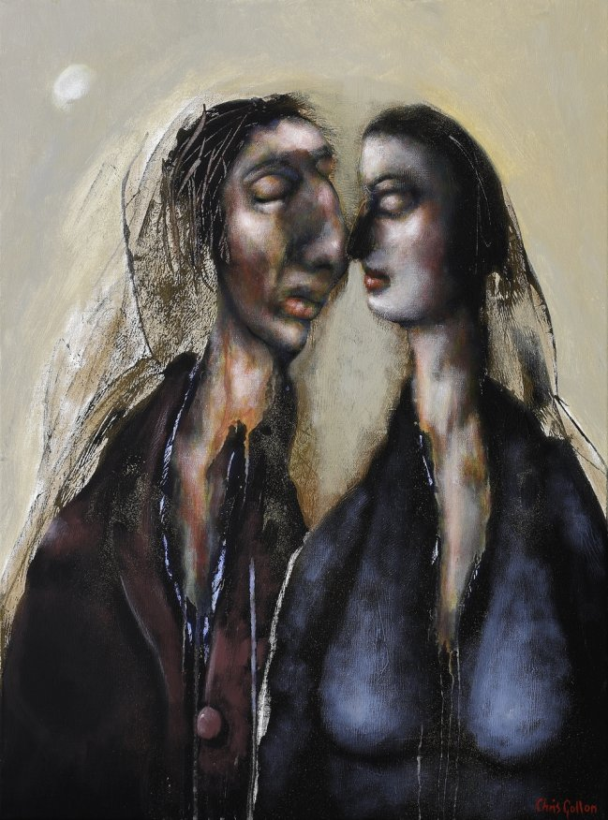

‘Love (II)’ by Chris Gollon, 24” x 18” (61 x 46cm) acrylic on canvas 2011. © Chris Gollon Estate

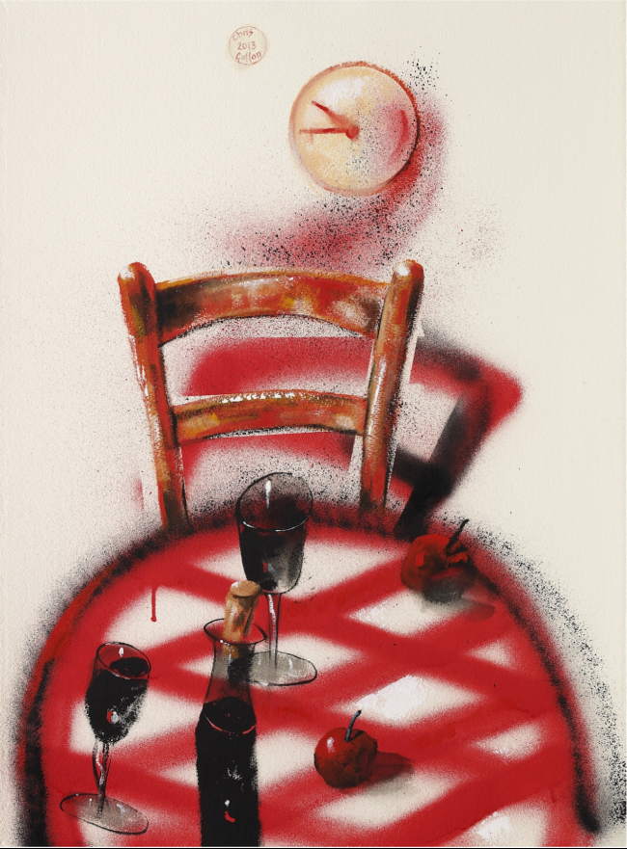

‘Still Life with Check Tablecloth’ by Chris Gollon, 30” x 22” (76 x 56cm) acrylic on paper 2013. © Chris Gollon Estate

